

AMERICAN INTERNATIONAL UNIVERSITY-BANGLADESH
Faculty of Engineering

Lab Report

Experiment #10
Experiment Title: Familiarization with the Raspberry Pi

Date of Perform: | 29 April 2026 | Date of Submission: | 06/05/2026
Course Title: | Microprocessor and Embedded Systems Lab
Course Code: | EEE4103 | Section: | B
Semester: | Spring 2024-25 | Degree Program: | BSc in CSE/EEE
Course Teacher: | PROTIK PARVEZ SHEIKH
Declaration and Statement of Authorship:
- I/we hold a copy of this Assignment/Case Study, which can be produced if the original is lost/damaged.
- This Assignment/Case Study is my/our original work; no part has been copied from any other student’s work or any other source except where due acknowledgment ismade.
- No part of this Assignment/Case Study has been written for me/us by any other person except where such collaboration has been authorized. by the concerned teacher and is acknowledged in the assignment.
- I/we have not previously submitted or am submitting this work for any other course/unit.
- This work may be reproduced, communicated, compared, and archived to detect plagiarism.
- I/we permit a copy of my/our marked work to be retained by the Faculty Member for review by any internal/external examiners.
- I/we understand that Plagiarism is the presentation of the work, idea, or creation of another person as though it is your own. It is a form of cheating and is a very serious academic offense that may lead to expulsion from the University. Plagiarized material can be drawn from, and presented in, written, graphic, and visual forms, including electronic data, and oral presentations. Plagiarism occurs when the origin of the source is not appropriately cited.
- I/we also understand that enabling plagiarism is the act of assisting or allowing another person to plagiarize or copy my/our work.
* Student(s) must complete all details except the faculty use part.
** Please submit all assignments to your course teacher or the office of the concerned teacher.

Group # 04

Sl No | Name | ID | PROGRAM | SIGNATURE
1 | MD KAWSAR KHAN | 23-50192-1 | BSc in EEE
2 | ROMAISHA ZANNAT | 23-55881-3 | BSc in CSE
3 | MD. MOTAHER HOSSEN SHEAK | 23-50615-1 | BSc in EEE
4 | FARDIN AHMED | 22-49566-3 | BSc in EEE
5 | MD. NAZMUL ALAM | 22-48525-3 | BSc in EEE

Faculty use only
FACULTY COMMENTS | Marks Obtained
 | Total Marks

Table of Contents
Objectives 3
Theory and Methodology 3
Equipment List 4
Circuit Diagram 4
Experimental Output Results 5
Simulation Output Results 10
Answers to the Questions in the Lab Manual
Discussion 16
References

Marking Rubrics (to be filled by Faculty):

Level Category | Excellent [5] | Proficient [4] | Good [3] | Acceptable [2] | Unacceptable [1] | No Response [0]
Title and Objectives | Able to clarify the understanding of the lab, no issues are missing and formatting is good. | Able to clarify the understanding of the lab experiment, no issues are missing but its formatting is not good. | Able to clarify the understanding of the lab experiment, but a few issues are  wrong, and its formatting is bad. | Able to clarify the understanding of the lab experiment, but it lacks a few important issues of  the experiment without maintaining the format. | Unable to clarify the understanding of the lab experiment. | No Response/ copied from others/ identical submissions with gross errors/image file printed
Codes and Methods | Able to explain the experimental codes and simulation methods using Proteus very well. | Able to explain the experimental codes and simulation methods using Proteus but is not formatted well. | Able to explain the experimental codes but simulation method using Proteus is not  explained well. | Presents the experimental codes but didn’t explain simulation methods using Proteus clearly. | Presents the experimental codes but didn’t explain simulation methods using Proteus.
Results | Key results and images are there. Figures/Tables have all identifications and refer to them properly in the texts. | Key results and images are there. Figures/Tables have all identifications, such as the axis labels, numbers, and captions with a few minor errors; the texts refer them. | Key results and images are there. Figures/Tables lack a few identifications, such as the axis labels, numbers, and captions; the texts  refer them. | Misses several key results and images. Figures/Tables lack identification, such as the axis labels, numbers, and captions; the texts don’t refer them. | Major results, such as experimental and  simulation results’ images are not included. Figures and tables are poorly constructed or not  presented.
Discussion and Conclusion | Proper interpretation of results and summarizes the results to draw a conclusion, discusses its applications in real-life situations to connect with  the report’s conclusion. | Proper interpretation of results and summarizes the results to draw a conclusion but didn’t discuss its applications in real-life situations to connect with  the conclusion of the report. | Interpretation of results is presented. However, there is a disconnect between the results and discussion. | Misses the interpretation of key results. There is little connection between the results and discussion. | Very poor interpretation of the results. No connection between results and discussions.
Question and Answer | Able to produce all questions’ answers  correctly maintaining the lab report format. | Able to produce all questions’ answers but didn’t maintain the lab report format. | Able to produce all questions’ answers but wrong answers to a few questions. | Able to produce all questions’ answers but wrong/missing answers to multiple questions. | Unable to produce all questions’ answers and completely wrong answers.
Comments |  |  |  |  |  | Total Marks (25)

Title: Familiarization with the Raspberry Pi

Objectives
The objectives of this experiment are to-

- Familiarize the students with the Raspberry Pi.
- Make an LED blink using the Raspberry Pi and its time.sleep() function.
- Control the LEDs’ ON/OFF using the input push switch.
- Implement a traffic light control system.

Theory and Methodology
The Raspberry Pi is a compact, affordable single-board computer developed by the Raspberry Pi Foundation in the United Kingdom. Its primary aim is to promote the learning of computer science and programming skills, particularly in schools and in developing countries. Despite its small size and low cost (typically between $5 to $75), it is a powerful tool capable of running full operating systems and supporting a wide variety of hardware interfaces.
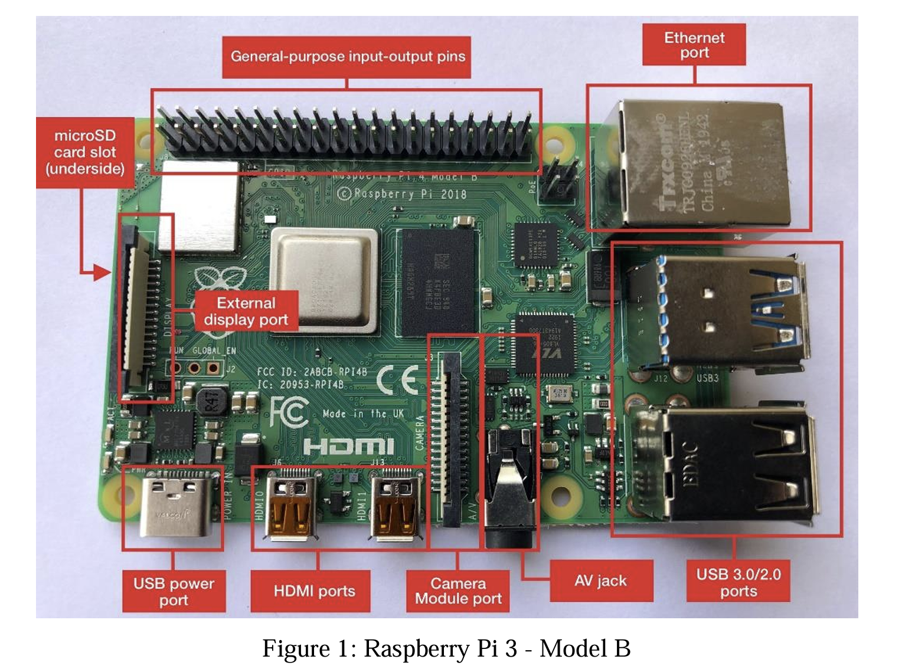
The Raspberry Pi functions similarly to a traditional PC—it can be used for tasks such as word processing, web browsing, programming, media playback, and more. Additionally, it allows for direct hardware interaction via GPIO (General Purpose Input Output) pins, making it an excellent platform for embedded system development, robotics, IoT applications, and electronics prototyping.
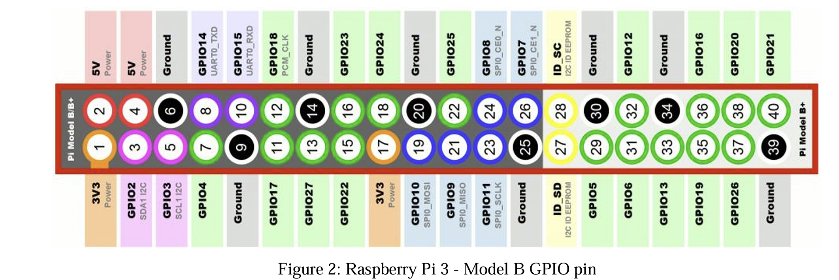
In this lab, we will be working with the Raspberry Pi 3 Model B, which includes features such as a 1.2 GHz 64-bit quad-core ARM Cortex-A53 processor, 1 GB RAM, built-in Wi-Fi and Bluetooth, HDMI output, and USB ports. Through hands-on tasks such as blinking LEDs and controlling outputs via Python scripts, students will gain foundational experience with Linux-based systems, GPIO programming, and basic interfacing techniques using Python.
This experiment provides the groundwork for further learning in embedded systems, digital electronics, and practical computing.

Equipment List:
  - Activated Raspberry pi
  - LEDs (GREEN,YELLOW AND RED)
  - Push switch
  - Resistor (220Ω)
  - Breadboard
  - Jumper wires

Circuit Diagram:
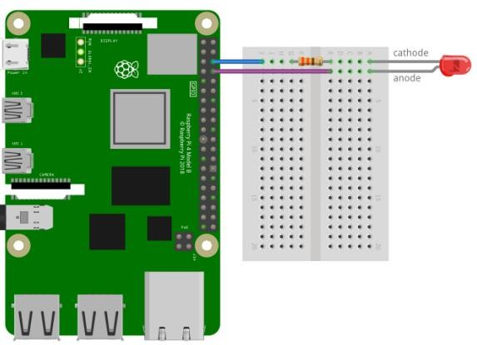
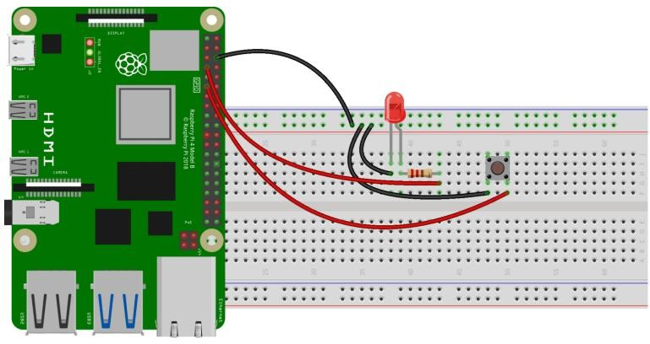
Fig 1: Circuit for the LED blinking program Fig 2: circuit for the LED controlling
experiment using a button switch.

Experimental Output Results:

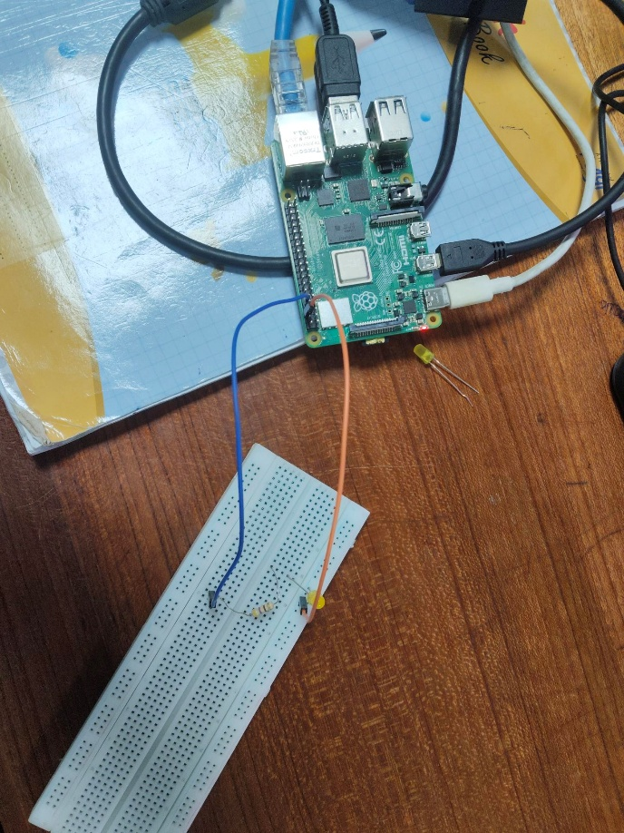

Fig 3: LED blink test(When LED is off)

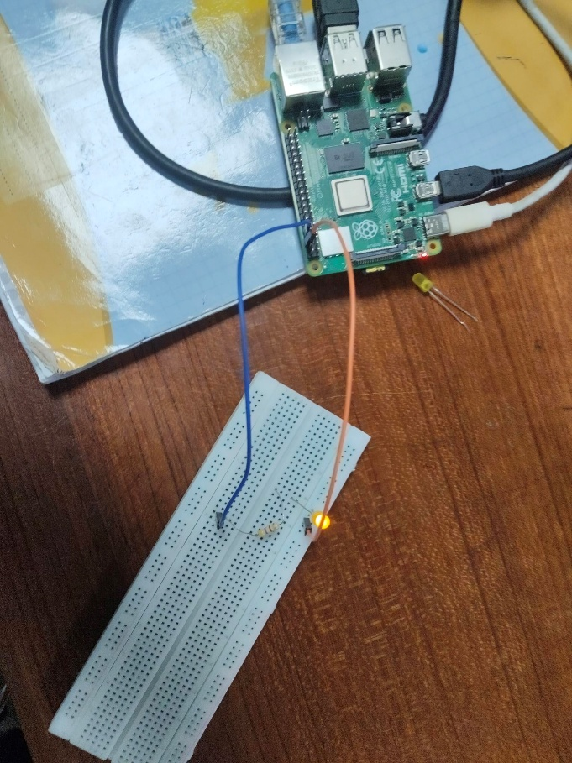

Fig 4: LED blink test(When LED is on)
Explanation: In this setup, a single LED is controlled using a Raspberry Pi and the RPi.GPIO library. The circuit is built by connecting a standard LED to GPIO pin 14 of the Raspberry Pi, with an appropriate current-limiting resistor in series. The Raspberry Pi is programmed to operate in BCM pin numbering mode, which maps physical pins to their GPIO designations. To ensure smooth operation during repeated code executions, warnings are disabled using the GPIO.setwarnings(False) function. Once the GPIO pin is configured as an output, the LED is turned ON by sending a HIGH signal to pin 14. A message stating "LED is ON" is printed in the terminal for user confirmation. After a delay of 2 seconds using time.sleep(2), the LED is turned OFF by setting the pin to LOW, followed by the message "LED is OFF."

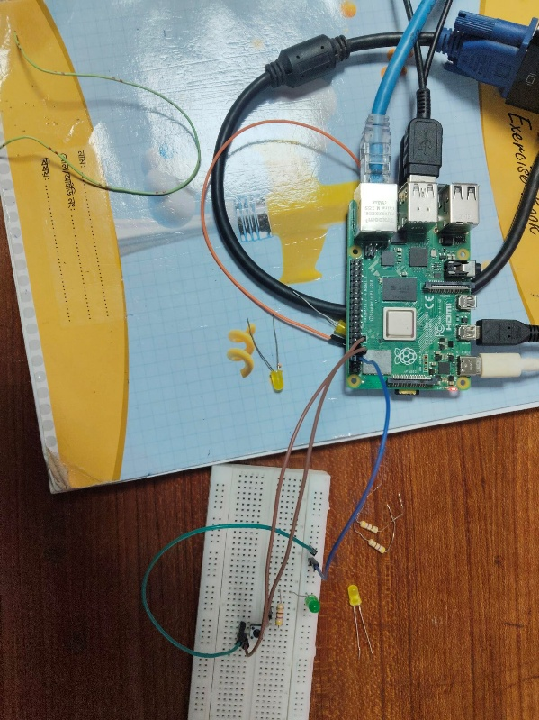

Fig 5: push button LED activation (Button not pressed LED OFF)
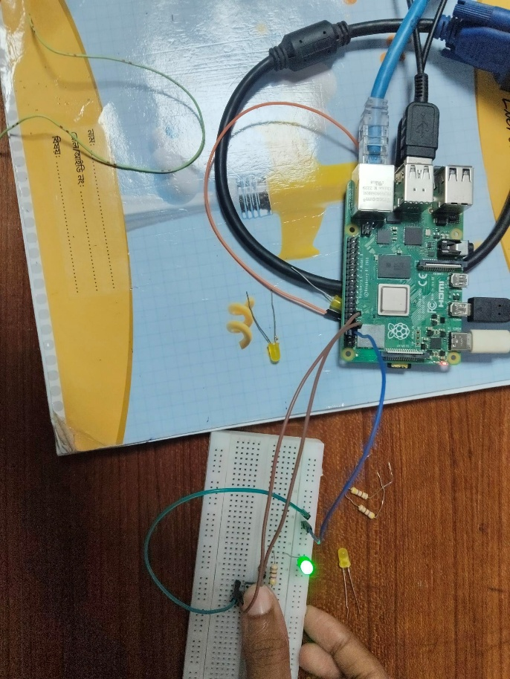
Fig 6: push button LED activation (Button pressed LED ON)

Explanation: In this setup, a push-button switch is used in conjunction with an LED and a Raspberry Pi to demonstrate simple digital input and output interaction using the gpiozero library. The LED is connected to GPIO pin 4 and controlled through the LED class, while the push-button is attached to GPIO pin 17 and managed using the Button class. Both components are initialized in the code and stored in respective variables led and button. The system runs an infinite loop where the Raspberry Pi waits for the button to be pressed using the wait_for_press() method. When the button is pressed, the LED is turned on immediately by calling led.on(). The system then waits until the button is released using wait_for_release(), after which the LED is turned off by invoking led.off(). This cycle continues indefinitely. During testing, each time the button is pressed, the LED lights up, and it switches off upon release.

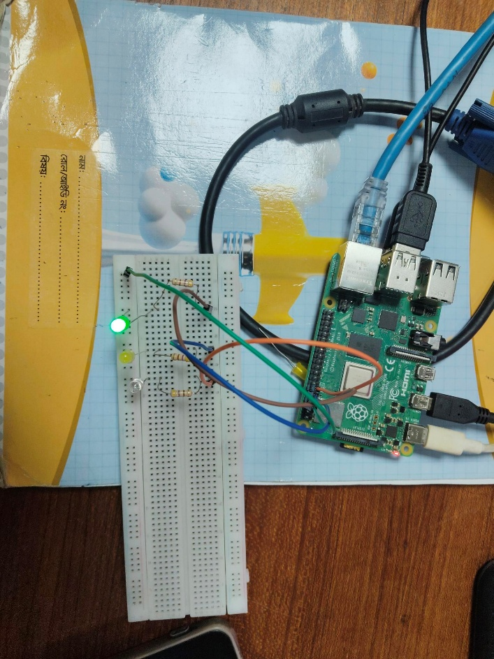
Fig 7: Traffic Control system(When Green LED is on)

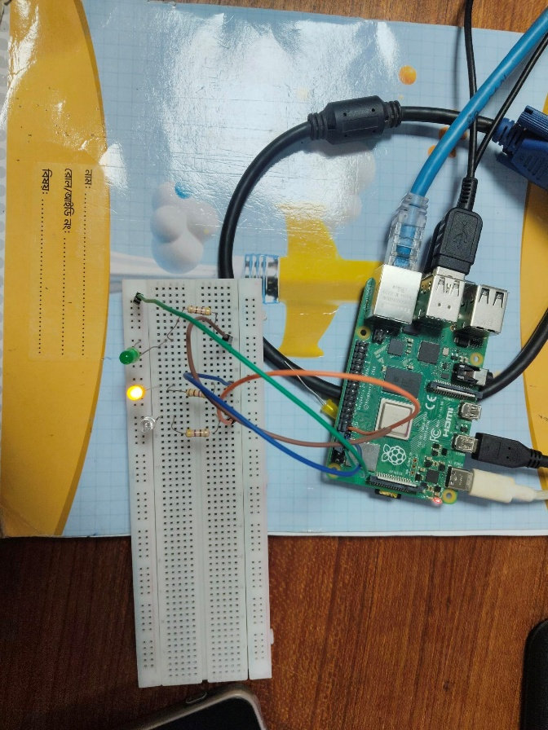
Fig 8: Traffic Control system(When Yellow LED is on)
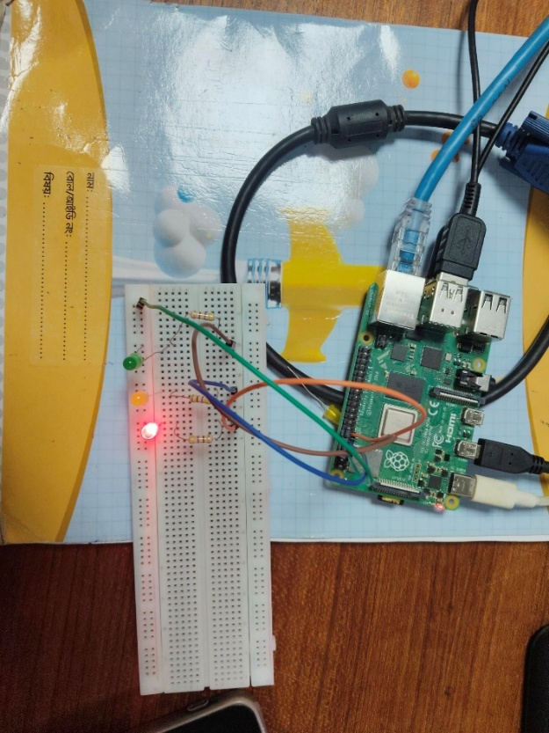
Fig 9: Traffic Control system(When RED LED is on)

Explanation: In this setup, a simple traffic light control system is implemented using a Raspberry Pi and three LEDs representing the standard traffic signal colors: green, yellow, and red. The green LED is connected to GPIO pin 14, the yellow LED to GPIO pin 15, and the red LED to GPIO pin 18. These pins are set as output using the GPIO.setup() function. The Raspberry Pi uses the BCM (Broadcom) pin numbering system, and warnings are disabled using GPIO.setwarnings(False) to avoid unnecessary alerts during repeated executions.The main logic is placed inside an infinite while loop, allowing the traffic light sequence to run continuously. First, the green LED turns on for 1 second to indicate that vehicles may proceed, after which it turns off. Next, the yellow LED blinks three times, each blink lasting 0.5 seconds on and 0.5 seconds off, representing the caution signal before stopping. Finally, the red LED lights up for 1 second to signal vehicles to stop. After this, the cycle repeats indefinitely. When observed during on real hardware, the LEDs operate sequentially in a recognizable traffic light pattern. The green LED stays on steadily, the yellow LED blinks to indicate transition, and the red LED lights up solidly. This simulation effectively demonstrates a basic traffic signal using digital output pins on the Raspberry Pi and can serve as a foundation for more advanced traffic control systems involving sensors or timers. Explanation: In this setup, a simple traffic light control system is implemented using a Raspberry Pi and three LEDs representing the standard traffic signal colors: green, yellow, and red. The green LED is connected to GPIO pin 14, the yellow LED to GPIO pin 15, and the red LED to GPIO pin 18. These pins are set as output using the GPIO.setup() function. The Raspberry Pi uses the BCM (Broadcom) pin numbering system, and warnings are disabled using GPIO.setwarnings(False) to avoid unnecessary alerts during repeated executions.The main logic is placed inside an infinite while loop, allowing the traffic light sequence to run continuously. First, the green LED turns on for 1 second to indicate that vehicles may proceed, after which it turns off. Next, the yellow LED blinks three times, each blink lasting 0.5 seconds on and 0.5 seconds off, representing the caution signal before stopping. Finally, the red LED lights up for 1 second to signal vehicles to stop. After this, the cycle repeats indefinitely. When observed during on real hardware, the LEDs operate sequentially in a recognizable traffic light pattern. The green LED stays on steadily, the yellow LED blinks to indicate transition, and the red LED lights up solidly. This simulation effectively demonstrates a basic traffic signal using digital output pins on the Raspberry Pi and can serve as a foundation for more advanced traffic control systems involving sensors or timers.

Simulation Output Results:
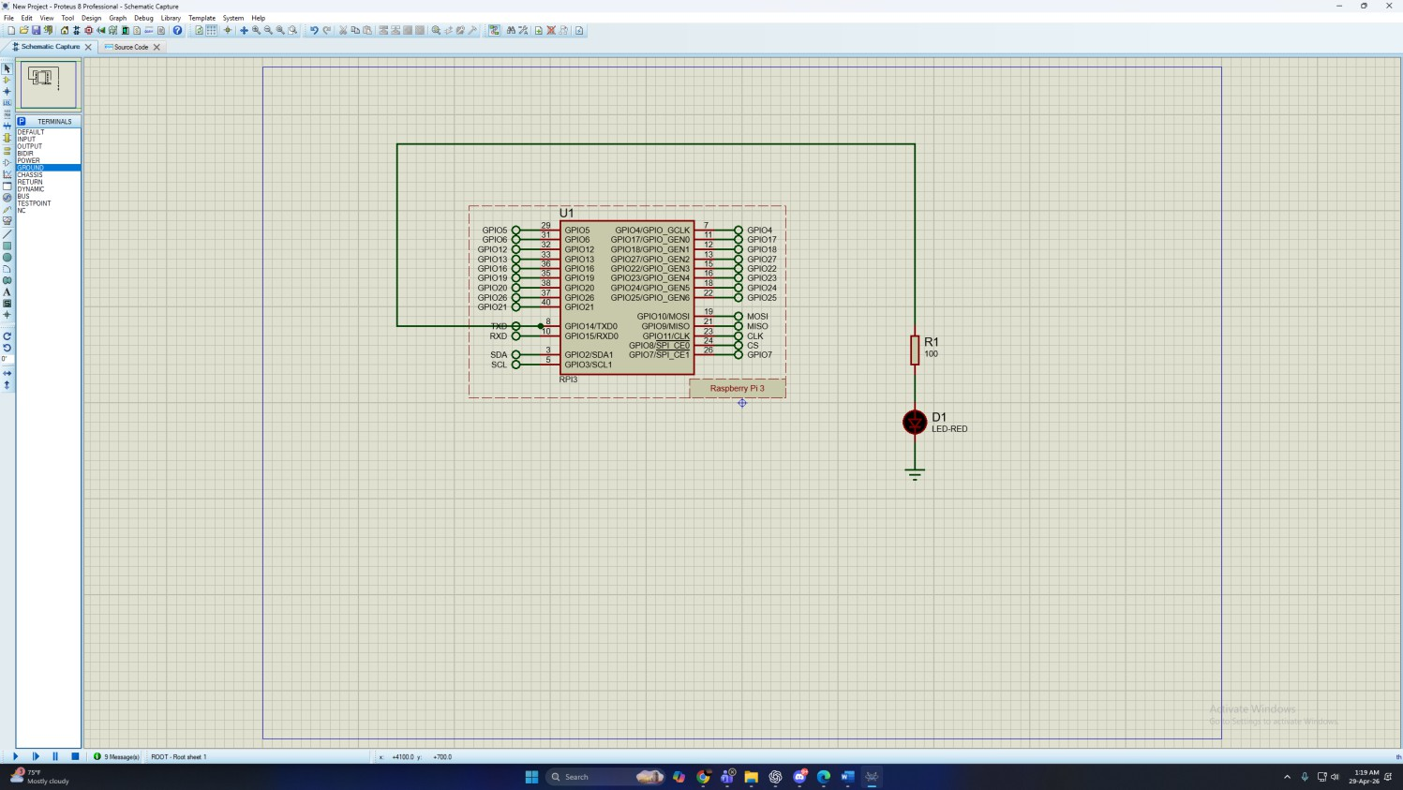
Fig 10: Simulation for LED blink test(When LED is OFF)
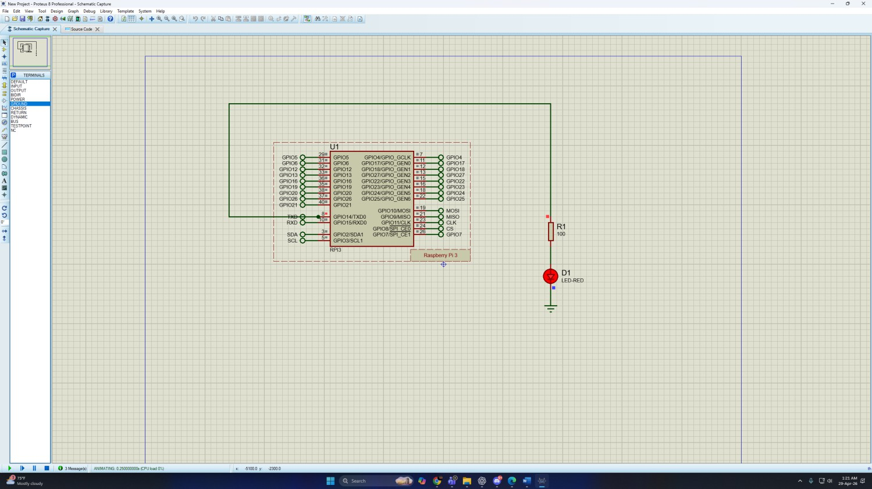
Fig 11: Simulation for LED blink test(When LED is ON)

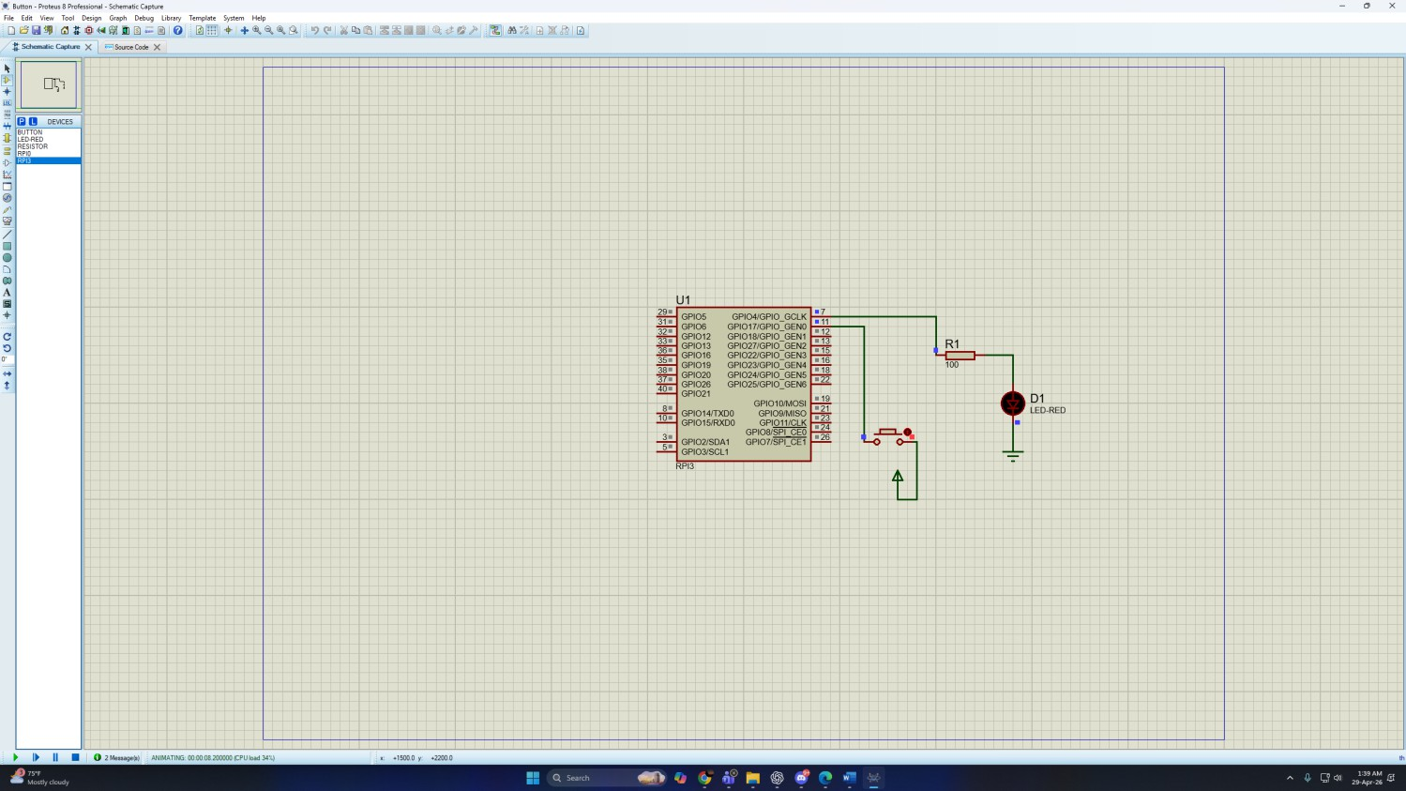
Fig 12: Simulation for push button LED activation (Button not pressed LED off)
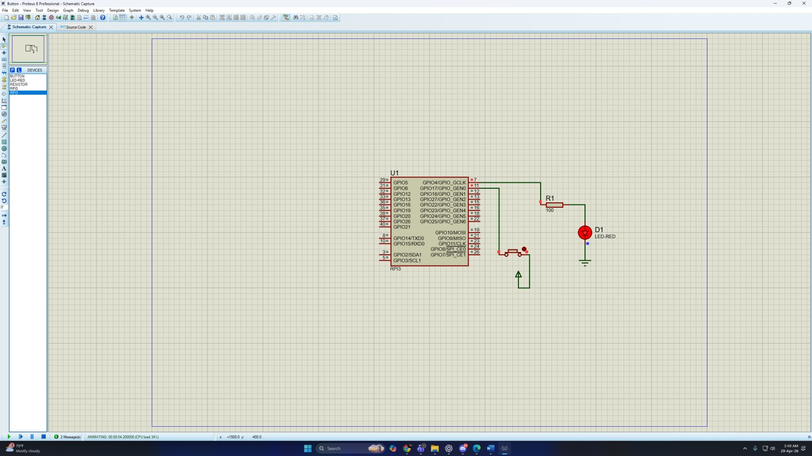
Fig 13: Simulation for push button LED activation (Button pressed LED on)

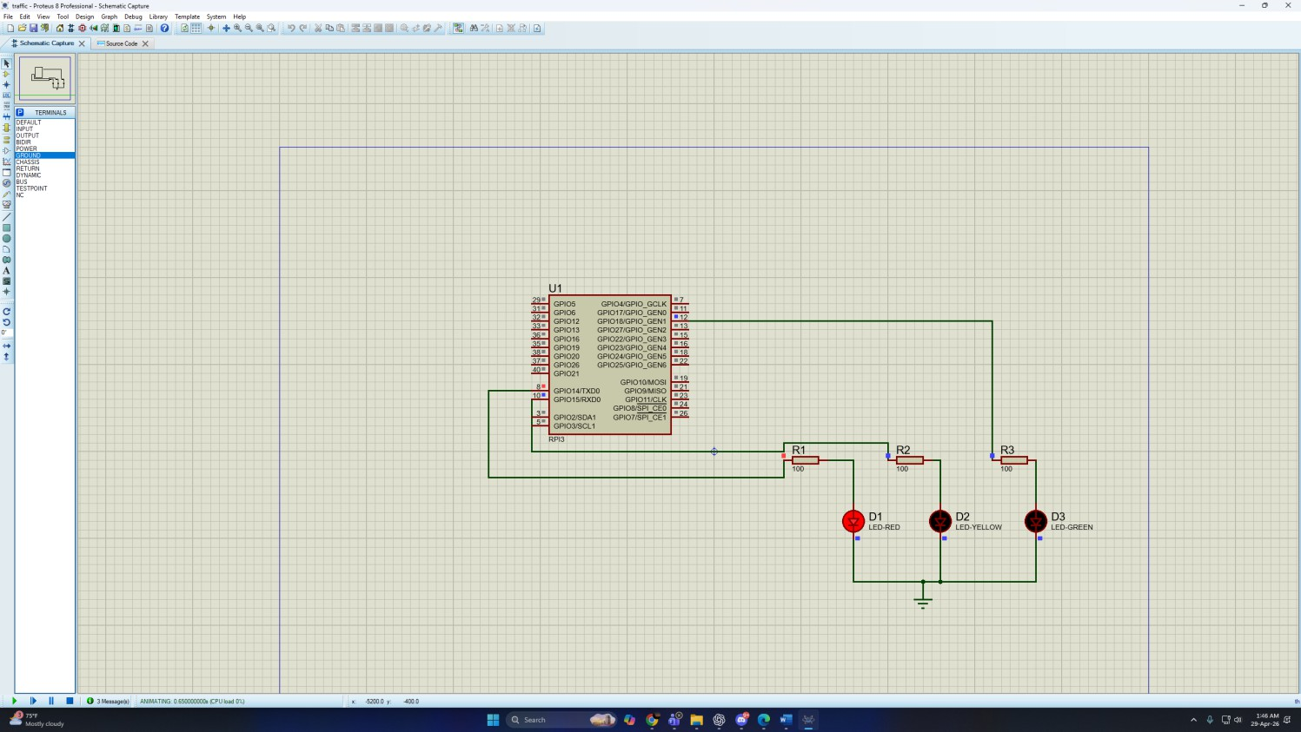
Fig 14: Simulation for Traffic Control system(When Red LED is on)
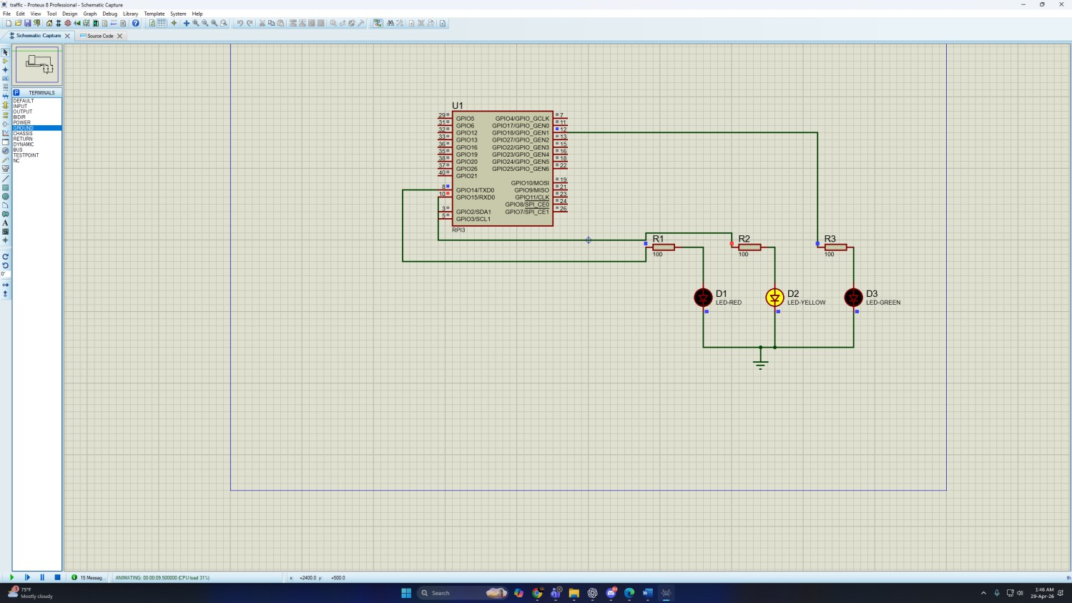
Fig 15: Simulation for Traffic Control system(When Yellow LED is on)

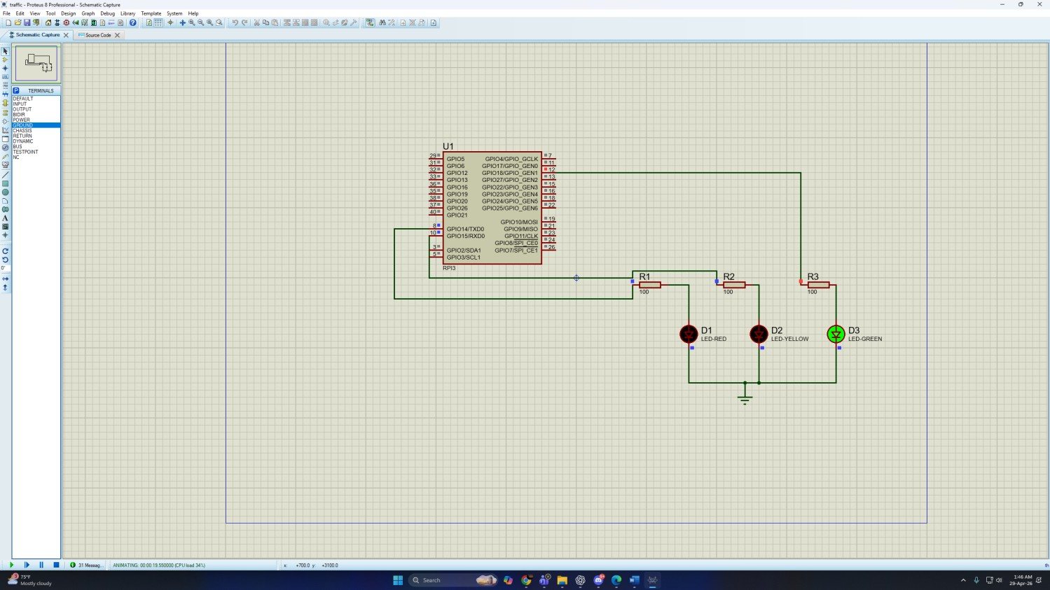
Fig 16: Simulation for Traffic Control system(When Green LED is on)

Explanation: In this simulation, a Raspberry Pi board was used to perform three tasks: LED blinking, push-button LED control, and a traffic light control system. Simulations were done using proteus, with Python code written using the gpiozero or RPi.GPIO libraries to control GPIO pins.For the LED Blink Test, an LED was connected to a GPIO output pin through a resistor. The program blinked the LED ON and OFF every second using time delays. This confirmed the correct functioning of GPIO output and timing control.In the Push-Button LED Control simulation, a push button was connected to a GPIO input pin and an LED to an output pin. When the button was pressed, the LED turned ON; when released, the LED turned OFF. This demonstrated real-time digital input handling and output response.For the Traffic Light Control System, three LEDs (green,yellow,red) were connected to separate GPIO pins. The LEDs were activated in a timed sequence to simulate traffic signals. Each LED stayed ON for a specific duration before the next turned ON, repeating in a continuous loop.Overall, these simulations validated the Raspberry Pi's GPIO control capabilities for automation and embedded system applications.

Code and Explanation:
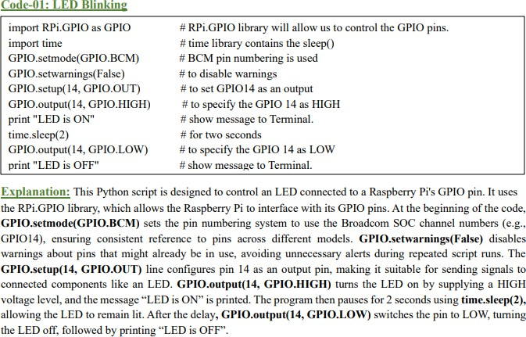
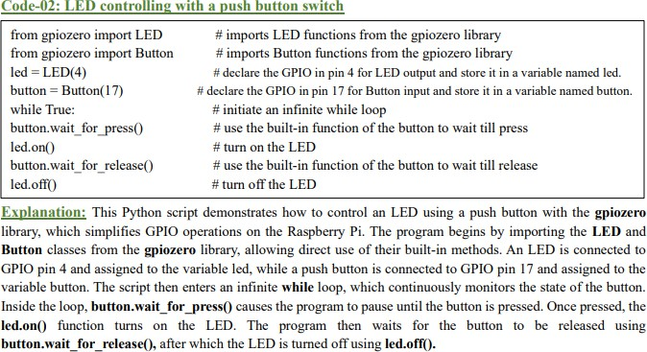

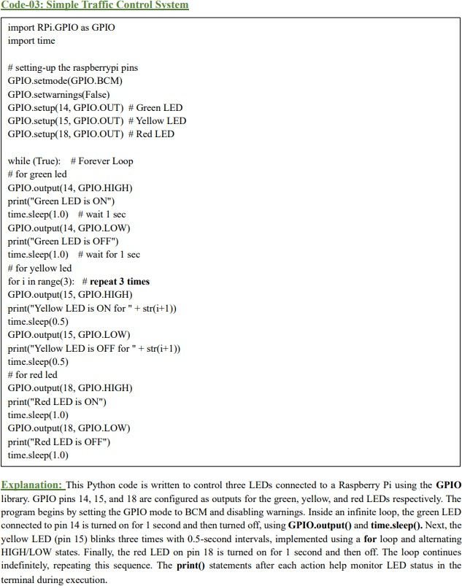

Discussion:
In this experiment, the Raspberry Pi was introduced as a small single-board computer that can be used for embedded system applications. The Raspberry Pi 3 Model B was used because it provides GPIO pins, USB ports, HDMI output, Ethernet, Wi-Fi, Bluetooth, and power supply support, making it suitable for basic hardware interfacing tasks. The GPIO pins were the main focus of the experiment because they allow external components such as LEDs and push buttons to be controlled through Python programs.
At first, a simple LED blinking circuit was implemented. The LED was connected to a GPIO pin through a current-limiting resistor, and the Python program controlled the LED by setting the GPIO pin HIGH and LOW. The time.sleep() function was used to create a delay, allowing the LED to remain ON for a certain time before turning OFF. This task helped demonstrate how software instructions can directly control hardware output.
The second task involved controlling an LED using a push button switch. In this part, the push button was used as an input device, while the LED worked as an output device. When the button was pressed, the LED turned ON, and when the button was released, the LED turned OFF. This showed the basic concept of input-output interfacing in embedded systems. It also demonstrated how Raspberry Pi can read input signals and respond by changing the output state.
Finally, a simple traffic light control system was designed using red, yellow, and green LEDs. This task applied the concept of sequential control, where each LED turns ON and OFF according to a fixed timing sequence. The use of loops allowed the traffic light pattern to repeat continuously. This task is important because it represents a real-life embedded system application where timing, control logic, and hardware interfacing are combined.
Overall, the experiment successfully demonstrated basic Raspberry Pi GPIO programming using Python. It provided practical knowledge about LED control, push button input, timing delay, and traffic light sequence design. Some possible errors in the experiment could occur due to loose jumper connections, incorrect GPIO pin selection, wrong resistor placement, or insufficient power supply. Therefore, proper circuit connection, correct coding, and careful checking of GPIO pin numbers are essential for accurate results.

References:
- Raspberry Pi Foundation. (n.d.). Getting Started with Raspberry Pi. Retrieved from https://www.raspberrypi.org
- GPIO Zero Documentation. (n.d.). A simple interface to GPIO devices with Raspberry Pi. Retrieved from https://gpiozero.readthedocs.io
- https://www.arduino.cc/.

